

# ANNA UNIVERSITY - MIT CAMPUS

**ONLINE QUIZ MANAGEMENT**

**PROJECT**

Subject: Web Technology

Staff Name: Eliza Femi Sherley

*Submitted By:*

**Arun Kumar S**

(2018506021)

**Surya Prakash P**

(2018506129)

**Online Quiz Management Project**

The ONLINE QUIZ is a web application for to take online quiz in an efficient manner and no time wasting for checking the paper. The main objective of ONLINE QUIZ MANAGEMENT SYSTEM is to efficiently evaluate the candidate thoroughly through a fully automated system that not only saves lot of time but also gives fast results. Teachers give papers for students according to their convenience and time and there is no need of using extra thing like paper, pen etc. This can be used in educational institutions as well as in corporate world. Can be used anywhere any time as it is a web based application (user location does not matter). No restriction that examiner has to be present when the candidate takes the test. This Web Application provides facility to conduct online examination worldwide. It saves time as it allows number of students to give the exam at a time and displays the results as the test gets over, so no need to wait for the result. It is automatically generated by the server. Administrator(Teachers) has a privilege to create, modify and delete account for teachers. Teachers can create different tests and contexts for students. Students can register, login and select the test with their preference, and can see the results as well. Teachers can also evaluate different contexts. The entire quiz is divided into three sections, students are allowed to move to a any other section. It provides a competitive platform, where a student not only judges their knowledge/skill but also they can improve their knowledge/skill at the same time.

**Functionalities:**

* New Student registration.
* To conduct quiz.
* To conduct different contexts.
* Score evaluation.
* The product will provide the following features:

Admin:

* Create accounts.
* Check Students’ accounts.
* Create quizzes.

Student:

* Login
* If not registered,register in the Registeration page.
* Access to quiz and context.
* Can attend test any time with own preference.
* View Results.

OVERVIEW:

The online test created for taking online test has following stages

* Register
* Login
* Results

**Login:**

There is a quality login window because this is more secure than other login forms as in a normal login window there are multiple login are available so that more than one person can access to test with there individual login. But in this project there is only one login id i.e. administrator username and password by which a person enter the site. Hence it is more secure.

**Test:**

Test page is the most creative and important page in this project. It consists of 3 modules namely:

* Logical
* Aptitude
* Vocabulary

**Subject selection:-**

From the given choices the candidate can select his field for taking on with the test.

**Utilities:-**

It includes:-

After reading the instructions, Enter into test.

Select the question and answer.

* If correct means, it will appear Correct in the screen.
* If incorrect means, it will appear Incorrect in the screen.

Then the student cannot able to change the answer.

* Each question carries 1marks.
* Each section is having 15 questions respectively.
* Total mark is 45.

**TECHNOLOGIES USED:**

**Front end as:** Java swing

**Back end as:** Derby Server

**Database:** Microsoft access

**Querying language:** SQL

**Registration:**

**Admin:**

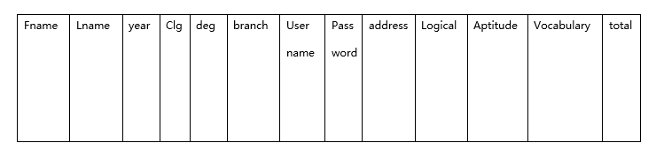

**Sections:**

|  |  |  |
| --- | --- | --- |
| Logical | Aptitude | vocabulary |

**Setting Questions:**

|  |  |  |  |
| --- | --- | --- | --- |
| Question no | Option 1 | Option 2 | Answer |

**Results:**

|  |  |  |  |  |
| --- | --- | --- | --- | --- |
| username | Logical marks | Aptitude marks | Vocabulary marks | Total marks |

**Screenshots:**

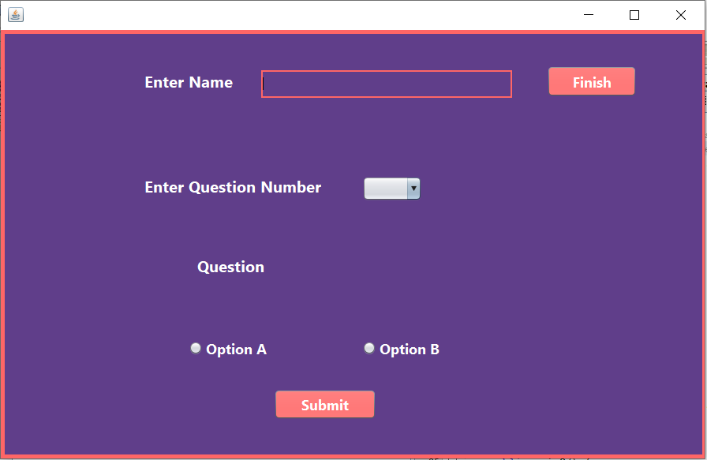

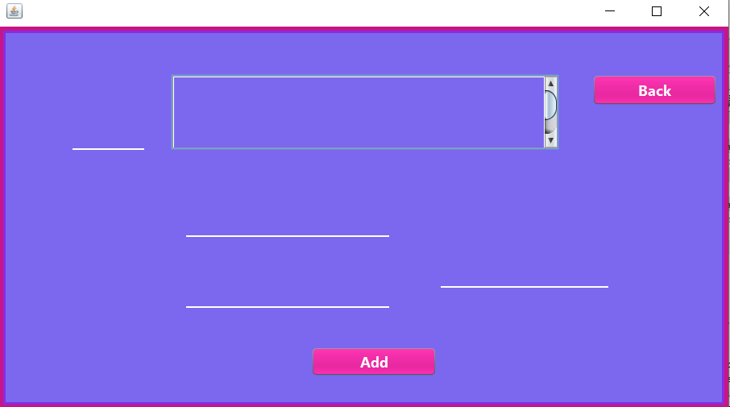

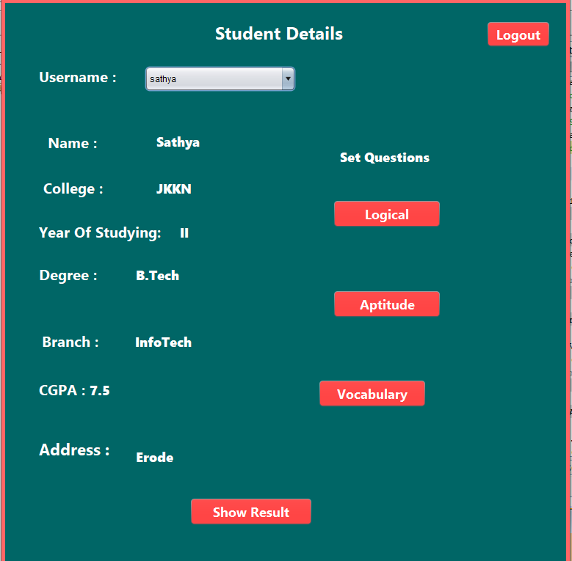

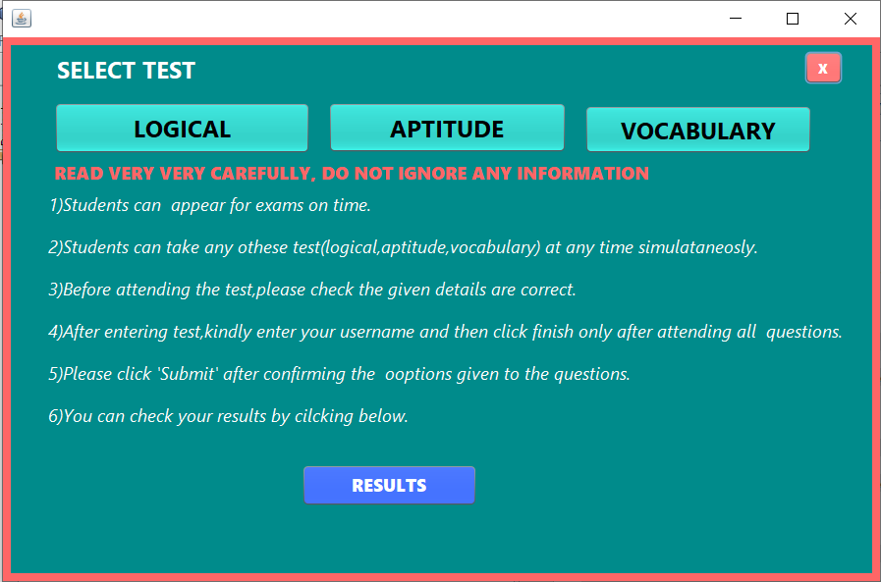

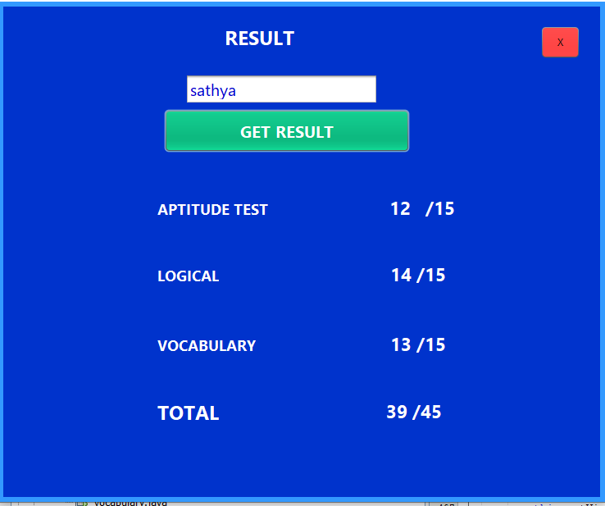

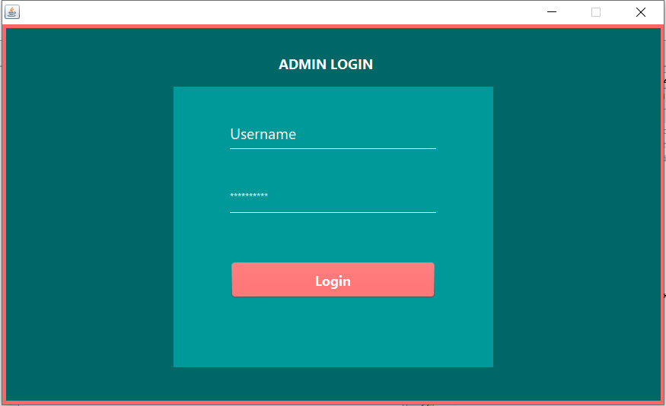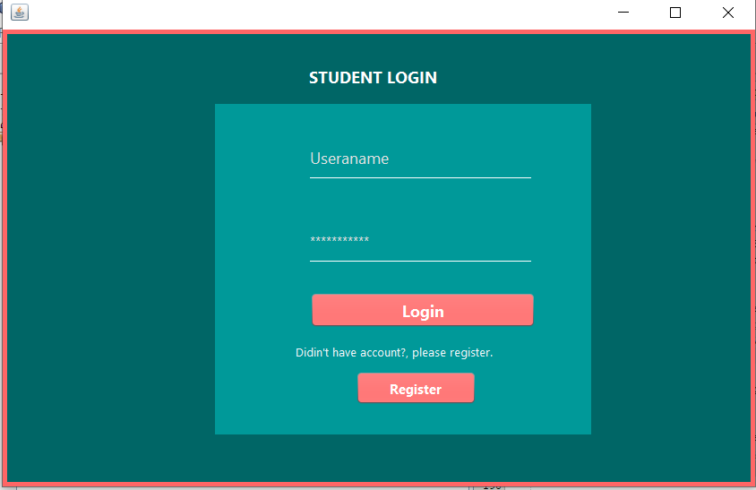

**Conclusion**

The Online Quiz System is developed using Java and SQL

fully meets the objectives of the system for which it has been developed. The system is operated at a high level of efficiency and all the teachers and user associated with the system understands its advantage. The system solves the problem. It was intended to solve as requirement specification.

**Future Scope**

Scope of this project is very broad in terms of other manually taking exams. Few of them are:-

* This can be used in educational institutions.
* Can be used anywhere any time (user location doesn’t matter).
* No restriction that examiner has to be present when the candidate takes the test.

Thank You